Field Trip Request Form 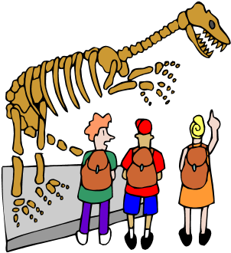
Bag Lunch can be provided for those students going on a Field Trip. Please select your choice and enclose payment. Lunch can be picked up in the cafeteria on the morning of the trip. THIS FORM MUST BE RETURNED TO SCHOOL WITH
PAYMENT INFORMATION (see below) PRIOR TO THE DAY OF THE TRIP. ORDERS WILL NOT BE ACCEPTED ON THE DAY OF THE FIELD TRIP.
Lunch Price $3.10 Free/ Reduced are also Eligible
Choice 1: Turkey & Cheese on a Roll
Veggie Sticks
Fruit
Juice
Milk

Choice 3: Smuckers PB&J Uncrustables
Cheese Stick
Veggie Sticks
Fruit
Juice
Milk ___________________________________________________________________________________
Name:____________________________________ Grade:______________________
Date of Trip:_________________________ Lunch Choice___________
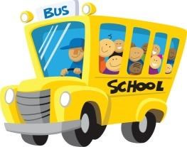
Payment must be enclosed with the order form.

